American Water
1
Imagine A Day Without Water

Survey Key Findings
OP17658
September 23, 2021
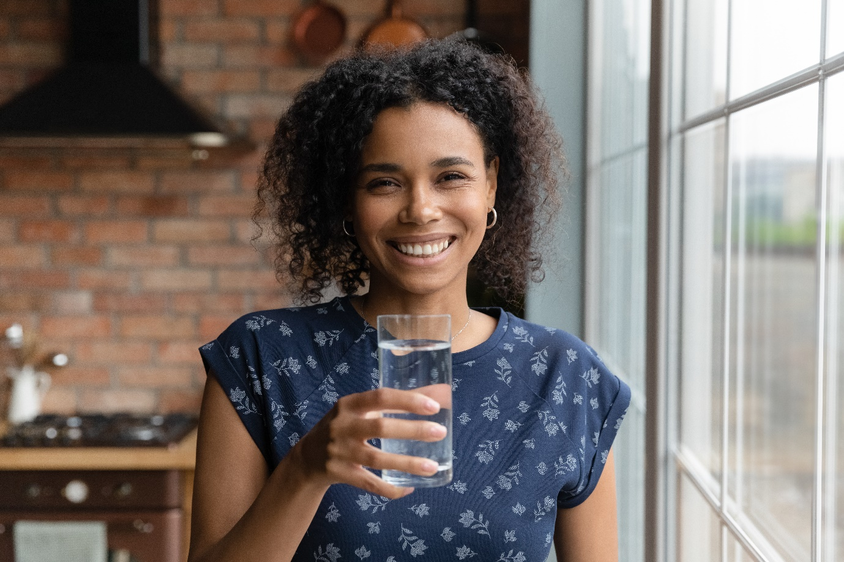
Assessing Americans’ water usage
Americans underestimate daily water consumption by over 90%
Americans estimate they use less than 100 (96.5) gallons of water per person each day, but the actual number is over 2,000 (according to National Water Footprint).

These figures consider water that is consumed directly (e.g. dishwashing or watering the lawn) and indirectly (e.g. the water required to produce food eaten).

Men, on average, estimate higher water consumption than women (140 gal vs. 60 gal), but neither group estimated anywhere near American’s calculated water footprint of 2,000 gallons per day.

Americans aged 18-24 had the closest estimate at 365 gallons, however, this is still more than 1,500 gallons off. The average estimate drops off steeply for Americans age 25-34 (41 gallons) and remains low throughout older generations as well. Homeowners estimate their consumption at nearly 130 gallons, compared to renters who believe they use only 33 gallons of water each day.

Regardless of gender, homeownership, or age, Americans are largely unaware of just how large their water footprint is and the variety of ways in which water supports our everyday lives.

Making a 16-pound holiday turkey uses 4,700 gallons of water — Americans think it takes only 160
With fall right around the corner, Americans are looking forward to indulging in the season’s specialties – like pumpkin spice lattes, crisp apples, and holiday dinners. However, there’s little knowledge of just how much water goes into producing these fall-favorites. Americans drastically underestimated the water needed to make one 16-pound holiday turkey (4,688 gallons vs. 158 estimated), a pecan pie (1,068 gallons vs. 135 estimated), and pumpkin pie (458 gallons vs. 135 estimated).

How many gallons do Americans think it takes to make the following…?
 | Estimated | Actual
16-pound holiday turkey | 158 | 4,688
Smartphone | 158 | 3,400
Pair of jeans | 160 | 2,600
Pecan pie | 135 | 1,086
Pumpkin pie | 135 | 458
Americans are also unaware of the amount of water it takes to produce items they use nearly every day. Almost 90 million Americans believe it takes no water at all to make a pair of jeans. In reality, a fresh pair of jeans requires around 2,600 gallons to make. Americans believe it takes 158 gallons of water to produce a smartphone, whereas it is more than 3,400.
Americans greatly overestimate how much water it takes to grow one average-sized apple (201 gal estimated vs. 33 gallons actual) or take a 5-min shower (116 gal estimated vs. 10 actual).

When it comes to popular drinks, Americans overestimate the water cost of an 8oz cup of brewed coffee (103 gal estimated vs. 37 gal actual), a pint of beer (155 gal estimated vs. 86 actual), and a pumpkin spice latte (97 gal estimated vs. 74 actual).
The water footprint of common food and drink items
When comparing the water footprint of common household food items (e.g., Tea/Coffee, Pork/Chicken, etc.), Americans generally know which one has the larger footprint, but there is room for improvement. On average, Americans scored a D+ and 59% correctly guessed the item that had the larger water footprint each time. Americans were stumped between rice and pasta – with 50% of Americans guessing rice and 50% of Americans guessing pasta. The correct answer is rice, which requires 299 gallons of water per pound to produce, whereas pasta requires 222 gallons per pound.

Finding ways to conserve more water
Nine in ten Americans are likely to try at least one new habit to conserve water next year
Generally, there is little resistance among Americans to incorporate water-conserving habits in the coming year, with 89% Americans likely to try at least one eco-friendly habit. Americans are most likely to wait for a full load to do laundry (64%), purchase local produce (62%), and use cold water to brush their teeth (58%). Around one in five Americans already use cold water to brush their teeth (18%) and wait for a full load to do their laundry (16%).
However, there are some changes Americans are more resistant to when it comes to conserving water — especially when it comes to diet. Two thirds of Americans would be unlikely to swap coffee for tea (32%), with one in five being extremely unlikely (20%). Over a quarter are unlikely to consume less meat and practice something like “Meatless Mondays” (28%) and one fifth are unlikely to swap beef or pork for chicken or turkey (20%).

Although open to water-saving practices, Americans lose millions of gallons of water to wasteful habits
Although Americans are willing to incorporate lifestyle changes to conserve more water, this isn’t always the case in practice. The most common wasteful activity Americans do is leave the faucet on while brushing their teeth, with one in five doing this every day (19%). Assuming people are brushing their teeth twice a day for a minute each time, this would waste 3 gallons of water each day (1.5 gallons each minute). With nearly twenty percent of the US adults doing this daily, that means around 149.9 million gallons of water are lost every day to this easily changeable task.
Younger Americans are wasting water more often. When it comes to running the dishwasher and washing machine without either being a full load, 18–24-year-olds do this on average 6.2 times and 6.5 times each month respectively. This is higher than the overall average for these two habits (3.3 and 3.4, respectively)
Despite using a hose to wash your car being one of the least common activities, it is the most wasteful. With Americans doing this on average 2.6 times each month, 2340 gallons of water are lost per person per year.

Americans appreciate having clean drinking water
Seven in ten Americans stop to appreciate having access to clean drinking water often
There’s no denying that access to clean drinking water is an incredibly valued commodity. Seven in ten Americans stop and appreciate this either very or fairly often in their lives (69%), with 50% doing this very often. This figure rises among those aged 65+ (79%) and decreases among those aged 18-24 (48%), which may suggest younger Americans to be more likely to take access to clean drinking water for granted.
Americans appreciate access to clean drinking water more often than they do waking up to a new day (66%) and having choice in their life (65%). Moreover, Americans appreciate access to clean drinking water more often than they do their morning coffee (52%) – despite being least likely to swap their coffee for tea as a means conserve water.

Survey Methodology: This survey was conducted online by global research agency Opinium on behalf of American Water from September 2nd to September 8th, 2021 among 2,006 US adults aged 18 and older. The sample was weighted to nationally representative criteria.

